October 2026

October has brought so many lovely memories to our nursery! Our children have enjoyed exploring autumn, getting creative with arts and crafts, taking part in exciting sensory activities and celebrating special occasions together. We have shared lots of laughter, smiles and wonderful learning experiences, watching our little ones grow in confidence, develop friendships and discover new things every day.

Dates for your diary
Nursery updates

This month has been full of exciting celebrations and meaningful experiences for our children!

Navratri (11th–19th October) – Our children celebrated Navratri, learning about this vibrant Hindu festival, its traditions and the importance of culture, music and dance.

World Smile Day (Friday 2nd October) – We celebrated the power of a smile, encouraging kindness, happiness and friendship while reminding our children how a simple smile can brighten someone’s day.

Harvest Appeal – Our children enjoyed a lovely walk to Morrisons to help stock up our Harvest Appeal box. This was a wonderful opportunity to teach them about kindness, sharing and helping others in our community.

It has been such an exciting month filled with learning, laughter, cultural experiences and opportunities to develop kindness and a sense of community! 💛

Thursday 29th October – Spooky Stay & Play 3:00pm–5:00pm
Join us for an afternoon of spooky fun! All our rooms are excited to showcase their wonderful invitations to play, filled with exciting activities and Halloween-themed experiences for children and families to enjoy together.

Wednesday 4th November – Nursery Christmas Photo Day
Our little ones will have the opportunity to capture some special memories during our nursery photo day.

Sunday 8th November – Diwali
On Monday the 9th of November we encourage all staff and children to wear their brightest and most colourful clothes. We will be celebrating the Festival of Lights by exploring different cultures and traditions through colourful crafts, stories, music and creative experiences.

Friday 13th November –Children in Need
Wear Yellow for Pudsey

Monday 16th November – Odd Socks Day
We will celebrate individuality, diversity and what makes each of us unique through fun activities and conversations about embracing our differences.

Nursery news
Nursery Practitioner Day – 16th October 2026
This year, Kensy, our Wellbeing Champion, and our directors, KB and Sri, celebrated Nursery Practitioner Day by treating the team and showing their appreciation for the incredible work, our Early Years Professionals do every day. 💛 It was a lovely opportunity to recognise the dedication, passion and care our practitioners bring to their roles, making a real difference in the lives of the children and families we support. A huge thank you to Kensy, KB and Sri for making our team feel valued, appreciated and celebrated! A special Thank you to all parents who wrote such lovely words regarding our team. I know hearing the nice things you said meant the world to them.
Employee of the month October 2026
Our Employee of the Month for October is Ellie Baines! Ellie has been covering in our Mini Moons room and has been an incredible support to the team. She has shown great dedication and teamwork, confidently guiding her colleagues through the recent audit and ensuring everything ran smoothly. Thank you, Ellie, for all your hard work, positivity and commitment! You are truly appreciated.


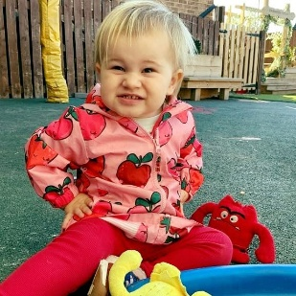
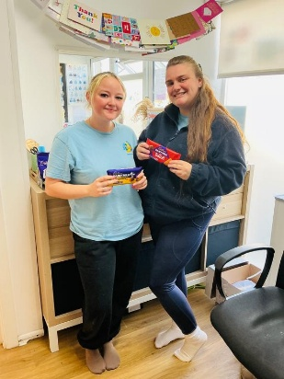

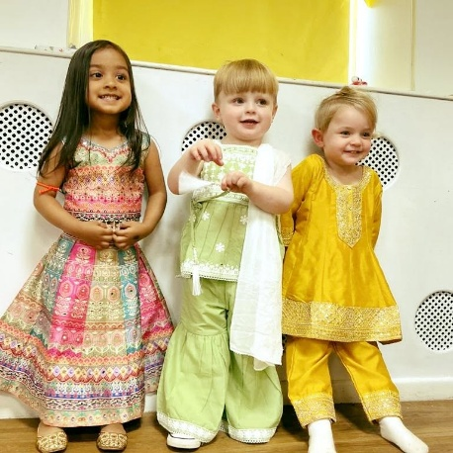
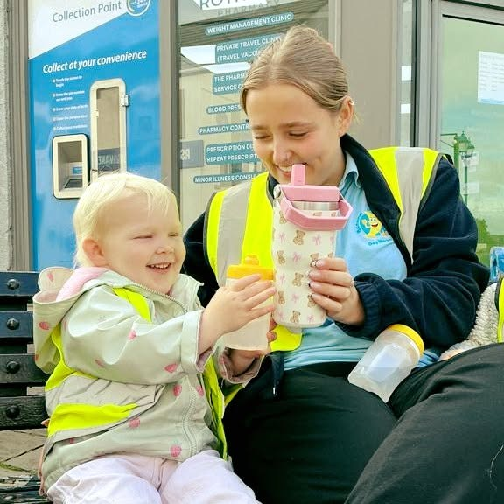
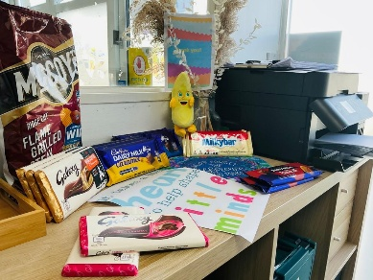

From all the team at Banana Moon Nursery Rothwell.

https://www.facebook.com/BananaMoonRothwell
https://www.instagram.com/bmrothwell/

